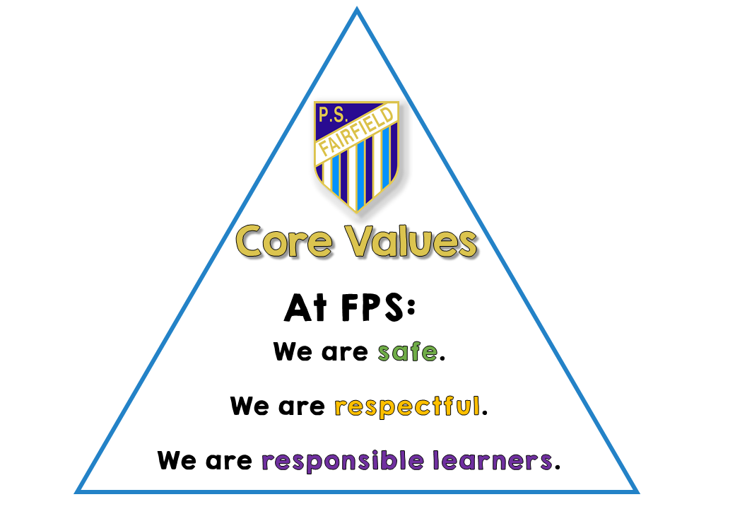

HOMEWORK POLICY

RATIONALE:
There is inconclusive evidence of the learning benefits of homework in infants and primary schools therefore homework is not compulsory. Quality homework, however, may benefit students.

AIM:

Through the implementation of this policy we aim to develop effective study habits and broaden students’ understandings and skills across the curriculum.

IMPLEMENTATION:

Fairfield Public School follows the NSW Department of Education guidelines listed below.

Kindergarten:
Students are not expected to complete formal homework in kindergarten. Students may be given books to read at home and mathematical activities. Timeframe should be up to 10 minutes per day.

Year 1 and 2:
Students are expected to complete some formal homework. Some examples could include reading, writing, spelling and mathematical activities.
Timeframe should be up to 15 minutes per day.

Years 3-6:
Students may be expected to complete homework more independently. Students could be encouraged to read and practise English and mathematical concepts learnt at school. Homework across other areas of the curriculum may be set.
Timeframe
- Years 3 and 4 up to 30 minutes per day.
- Years 5 and 6 up to 60 minutes per day.

Homework should be meaningful and directly related to work covered in class. Students will not be asked to learn new things, homework should relate to work covered in class.

Homework will communicated to parents via a Homework proforma that will list activities to be completed. Teachers will send out the proforma in print and or electronic form on SeeSaw.

Evaluation review date February 2019

